Author Guidelines for Journal of Computational Vision and Imaging Systems
Parthipan Siva  Alex Wong | Aimetis Corp., ON, Canada  University of Waterloo, ON, Canada

Abstract
This template presents the author guidelines for all submissions for Journal of Computational Vision and Imaging Systems. Please ensure that all guidelines are followed prior to submission.

1. Introduction
Journal of Computational Vision and Imaging Systems provides a forum for the dissemination of research results and technical advances in the field of computer vision and imaging. The goal of the journal is to bring together both academia and industry to share their joint expertise to promote the advancement and application of computer vision and imaging technologies in various areas of academic and industrial interests. Journal of Computational Vision and Imaging Systems is published on an on-demand basis and is the official journal of the KWVIS Society.
Topics covered by the journal include, but are not limited to:
- Reconstruction, restoration, and enhancement
- Machine learning / Artificial intelligence
- Compression and transmission
- Content-based image retrieval
- Object detection, recognition, and classification
- 3D and stereoscopic imaging and reconstruction
- Multispectral imaging, processing, and analysis
- Video processing and analytics
- Biometrics processing and analysis
- Visual quality assessment of images and video
- Computational imaging
- Document and sign processing and analysis
- Applications to various fields (e.g., remote sensing, health monitoring, biomedical, consumer electronics, manufacturing, life sciences)

2. Format
All submissions to Journal of Computational Vision and Imaging Systems must follow the below requirements:
- Letter page size format
- Double-column format
- Maximum length of three pages, including all figures and references
- Must include a short abstract with a maximum of 150 words.
All citations should follow the format at the end of this template [1, 2].

3. Equations
All equations must include an equation number. An example equation is shown in Eq. 1:
y=ax+b (1)

4. Figures
All figures must include a figure number as well as associated caption. An example figure is shown in Fig. 1.

5. Conclusions
In conclusion, following this author guidelines will ensure that the submitted paper is in the proper format for publication in Journal of Computational Vision and Imaging Systems.

Acknowledgement
We thank you for reading these guidelines.

References
[1] Siva, P. and Wong, A. Author Guidelines for Journal of Computational Vision and Imaging Systems. Journal of Computational Vision and Imaging Systems (2015).
[2] Siva, P. and Wong, A. More Author Guidelines. Proc. ABCD (2015).
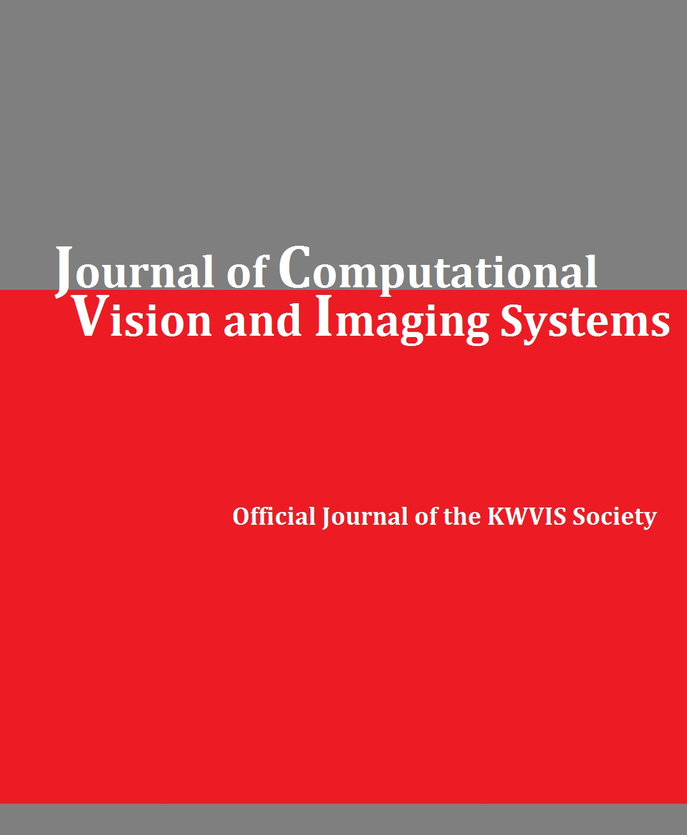
Fig. 1: Example figure for Journal of Computational Vision and Imaging Systems.

